**Use Case and Database Comparison**

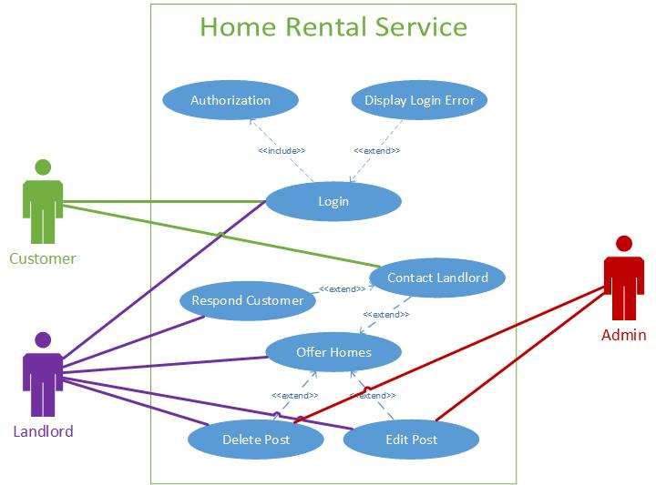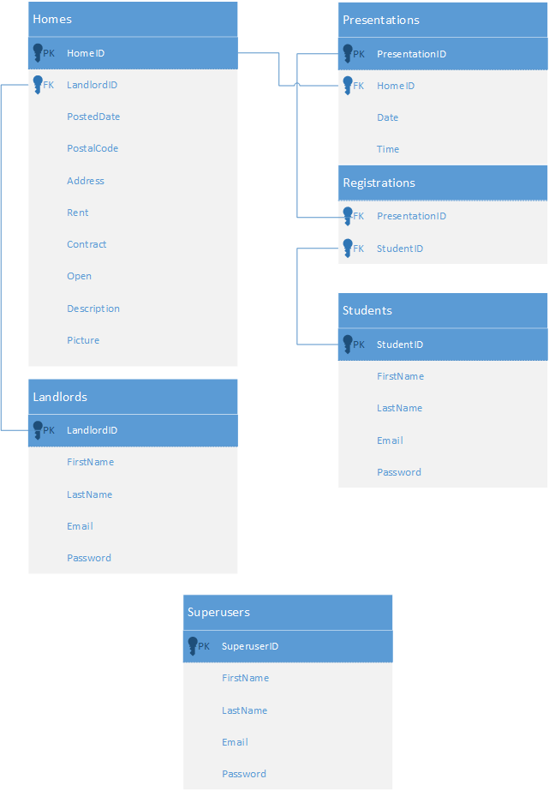

**Comparison**

The fields in the database are sometimes called slightly different. Admin is called superuser and customer is called student, but other than that, there is only major differences. The database obviously has some more details.

The biggest difference is that the database includes presentations, while the Use Case Diagram doesn’t. The presentations are ways where student can register themselves for a presentation of the home they like.